September 2, 2026

Welcome to the 2026 Cross Country Running Team at Sir John A Macdonald! We are very excited to have you join us. Being on this team helps contribute to a passion for sports, fitness, and development of teamwork and physical skills.

No tryouts are required, and all student-athletes who want to compete will be offered a position on the SJAM Cross Country team.

All Cross Country practices & meets will be listed on the SJAM Athletic Calendars found on our main Athletics page.

As a member of a school team, we expect you to be a proud representative of our school and learning community. In addition, we would like to emphasize the importance of continued academic and personal success combined with athletics.

TRAVEL ARRANGEMENTS
Students, together with their parents, are required to make travel arrangements to and from all cross country meets and must be picked up on time. The school will NOT provide any transportation to or from races.

EMERGENCY RESPONSE
If in the extremely rare situation an emergency situation does arise, all coaches or our principal will contact you via home/work/cell phone. Students will either be returned to Sir John A Macdonald or asked to be picked up on location depending on the emergency. Please ensure your contact information is updated with coaches as necessary.

BEHAVIOURAL EXPECTATIONS
As a member of a school team, students are seen as a leader in the school; consequently, a certain standard of conduct is required. Students are expected to demonstrate SJAM principles in their words, actions, and attitudes. Students who, in the opinion of the coaches or administration, do not meet this expectation will be excluded temporarily or permanently from the team. Please have your child refer to the Mustang Athletic Behaviour Document for further information.

HEALTH AND WELL-BEING
Please ensure that your child eats healthy, appropriate meals before practices and on race days. Athletes should also be well hydrated and have their own water bottle. Sharing of bottles is not encouraged. Cross Country running can be a very taxing sport and thus athletes need to prepare themselves accordingly. All adolescents should be aiming to get at least 8-9 hours of sleep at night. For athletes, this amount is essential in order to perform their best.
In addition to our practices, some of our staff will be running a “Fit-club” that the students can take part in. It provides an opportunity for our athletes to work on their overall fitness and general athletic development. This occurs Mondays from 3-4pm and Fridays from 7-8am.

SJAM GEAR & UNIFORMS
There are yellow SJAM t-shirts to use during the meets and can be obtained at the meet or before the races. These are the yellow t-shirts provided to all students for a fee. Please submit payment digitally through the Parent Portal of PowerSchool as we are not able to accept cash. Families can also come into the school, during regular business hours, to pay with a debit or credit card. Please note, It may take the CBE a couple of weeks to add this fee to your child's account. This will be added to their account post-season.

CONSENT AND ACKNOWLEDGMENT OF RISK
You are asked to complete the attached Consent and Acknowledgement of Risk form if you consent to your child attending this off-site activity. Information about the administrative regulations governing these forms can be found at https://cbe.ab.ca/GovernancePolicies/AR3027.pdf. Parents are reminded that even if a consent has been signed, you may withdraw your consent at any time.

While some degree of risk is always associated in all school off-site activity, I have outlined specific areas of concern on the Consent and Acknowledgement of Risk form. To prepare your child for these risks we ask you to ensure that you:

-Discuss with them the risks that are outlined in the Acknowledgement of Risk form.
-Review that they are expected to behave in a mature manner and check in with the teacher in charge upon arriving and before leaving the race.
-Make sure that they have a water bottle at all practices and meets, to ensure proper hydration.

Coaches have first aid training and cases of minor injury and/or illness will be dealt with by the coaches and parents will be contacted. In case of emergency, EMS will be contacted.

If you have any questions about this school off-site activity, please do not hesitate to contact me at miparsons@cbe.ab.ca In the event of modification of this off-site activity, I may send out a School Messenger. Secondly, you are welcome to contact our other Cross-Country coach Sarah McLellan at samclellan@cbe.ab.ca

Thank you,

McKenzie Parsons (Teacher-in-charge)  Construction and Fabrication Teacher  Sir John A. Macdonald School  Calgary Board of Education  t | 403-777-7670 | Sarah McLellan  (she/her)  Teacher, Grade 8 Science and Math  Sir John A. Macdonald School | website  Calgary Board of Education | www.cbe.ab.ca  T| 403-777-7670

MEET INFO, TIMES, LOCATIONS AND DATES

- Please arrive early (4:30pm at the latest) to allow for a check-in, warm-up, and course recon. Look for the SJAM tent
- Please check in with Mr. Parsons directly for attendance
  - If you haven’t signed the risk forms, you cannot race.
- Find your start time and location so you are ready
- Remain at the SJAM tent until you are called to your race
- After your race, check OUT with Mr. Parsons and you are free to leave whenever, but we recommend staying to cheer on your fellow Mustangs and show that Mustang Spirit!

There will be a total of 3 CMLSAA Cross Country Meets in the 2025-26 School Year:
 | Dates | Location | Time
Practice | Tuesday, September 8, 2026 | SJAM, back field | 3:00-4:00 pm
Meet | Thursday, September 10, 2026 | Vista Heights Soccer Field #11 (2616 16 St NE #11) | 4:40 pm start time.  4:15 arrival or earlier  Done by 6:30 pm latest
Practice | Monday, September 14, 2026 | SJAM, back field | 3:00-4:00 pm
Meet | Tuesday, September 15, 2026 | West Confederation Park (formerly named Canmore Park) (2032 Chicoutimi Drive NW) | 4:40 pm start time.  4:15 arrival or earlier  Done by 6:30 pm latest
Meet | Monday, September 21, 2026 | Rosemont Community Centre/Confederation Park (2807 10 St NW) | 4:40 pm start time.  4:15 arrival or earlier  Done by 6:30 pm latest
Back up meet | September 29, 2026 | Vista Heights Soccer Field #11 (Only if the planned final meet date is cancelled.) (2616 16 St NE #11) | 4:40PM-6PM

- MEET 1
- Thursday, September 10, 2026 @ Vista Heights Soccer Field #11 (2616 16 St NE #11)
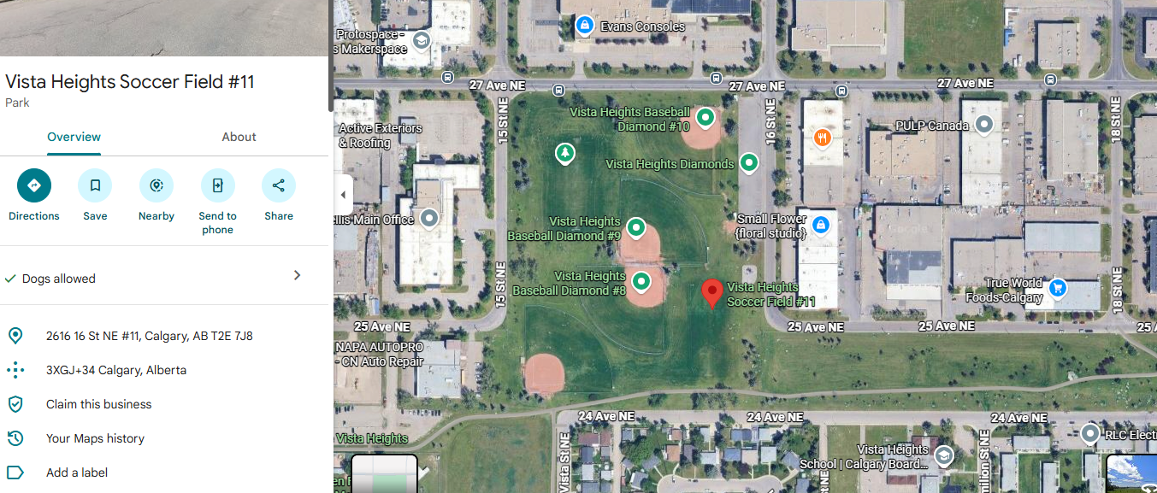
MEET 2
- Tuesday, September 15, 2026 @ West Confederation Park - formerly named Canmore Park. Runners may be dropped off at the Cardinals Baseball Diamond at the corner of 19th Street & Chicoutimi Drive NW. Park within the community of Triwood or along Canmore Road on the south side of West Confederation Park.
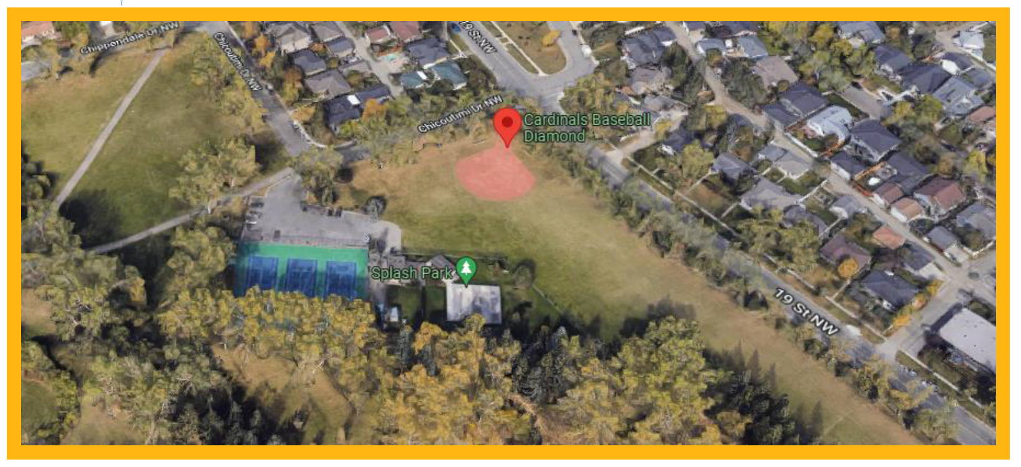
MEET 3
- Monday, September 21, 2026 @ Rosemont Community Centre/Confederation Park (2807 10 St NW) - This race starts and finishes next to the Rosemount Community Association building located at 2807 10 St NW. Limited parking available at both the Rosemount Community Association parking lot & the Confederation Park parking lot just off of 10th Street between Rosehill Drive & 23rd Avenue NW.
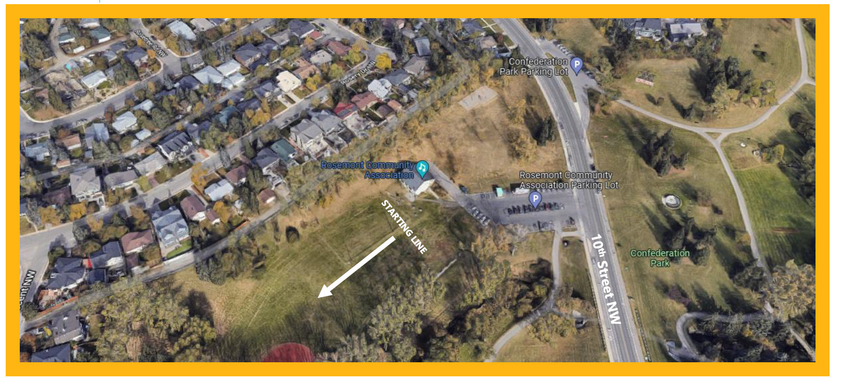
- Back Up Meet - September 29, 2026 @ Vista Heights Soccer Field #11 (Only if the planned final meet date is cancelled.) (2616 16 St NE #11)

- 4:40pm – Grade 6 Girls
- 4:50pm – Grade 6 Boys
- 5:00pm – Grade 7 Girls
- 5:10pm – Grade 7 Boys
- 5:20pm – Grade 8 Girls
- 5:30pm – Grade 8 Boys
- 5:40pm – Grade 9 Girls
- 5:50pm – Grade 9 Boys
The Grade 6 & 7 route is usually set between 1.5 & 2km. Grade 8 students will run between 2 & 2.5km and Grade 9 runners will usually cover a distance between 2.5 & 3km.

